|  |  |
| --- | --- |
| Guide  CHANG cinema system |  |

This user guide include for Client, Administrator (User) and Developer.

|  |  |
| --- | --- |
|  |  |

# REQUIREMENT

- Window/Mac OS/Linux with: 8Gb of Ram, 32bit or 64bit

- Java 1.8 (current version we use in this app is 8u270)

- Intelliji IDEA (Ultimate)

- SceneBuilder 1.8

# FOR USER

Our system serves 2 types of users who are moviegoers (client) and administrators.

1. Client

After the administrator has set up the base environment, the product can be used by the client.

Client choose the User side and click:

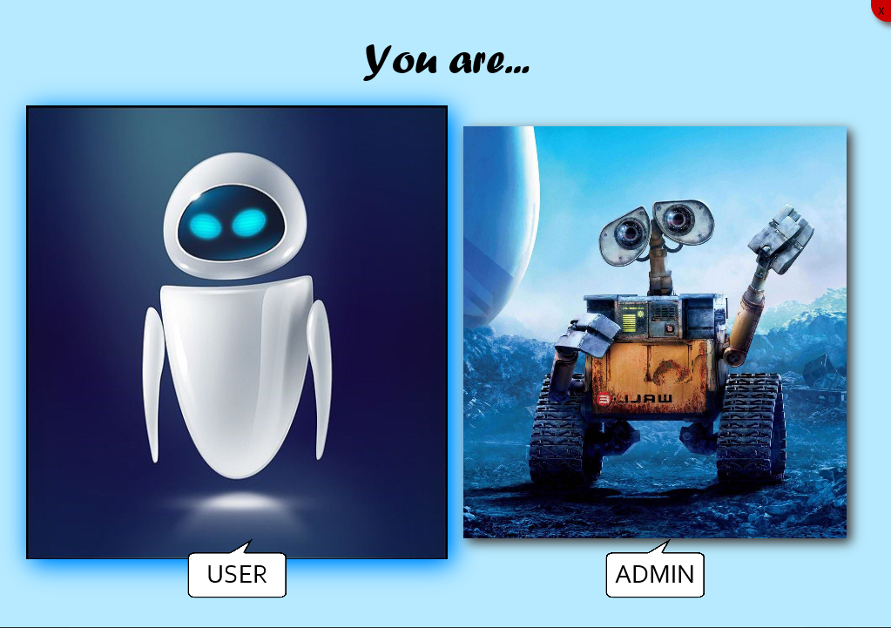

If the client really already has an account, you can log in directly.

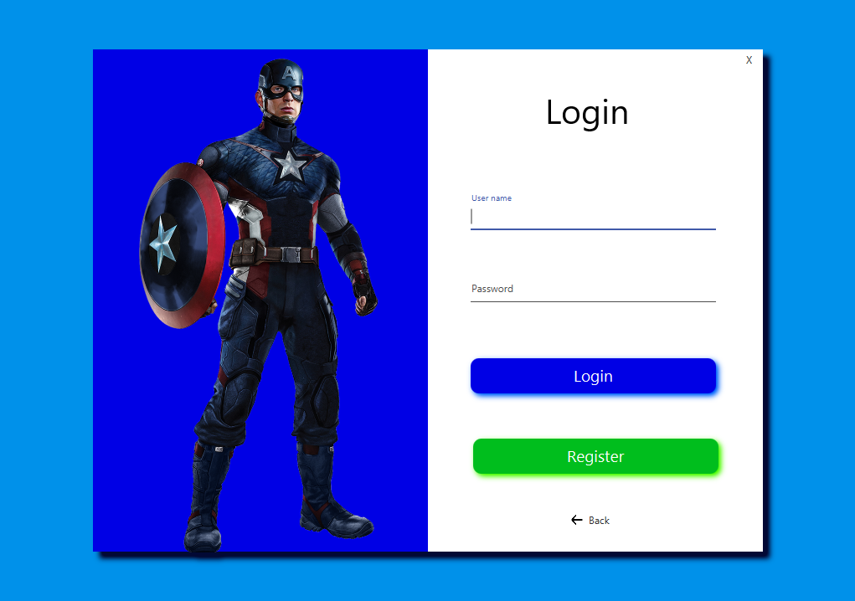

Or if not, you can register a new account by clicking the Register button:

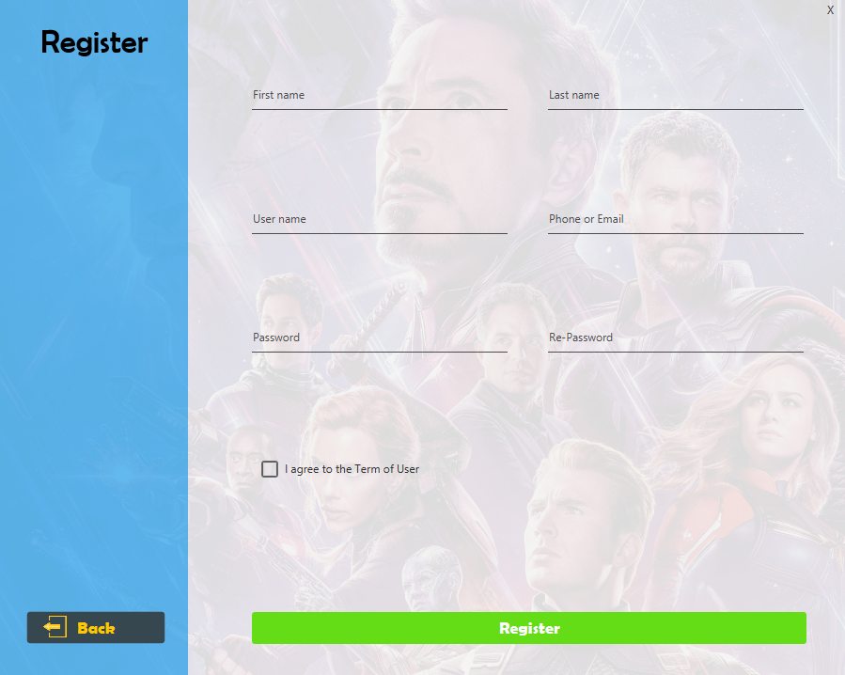

Sign up and complete the information, then tick the box Agree to the terms. If successful, the system will notify successful registration and return to the login screen so you can use your new account.

After login, the first page you see is custom your infor, every information you see in this picture below will be change by your information you registed:

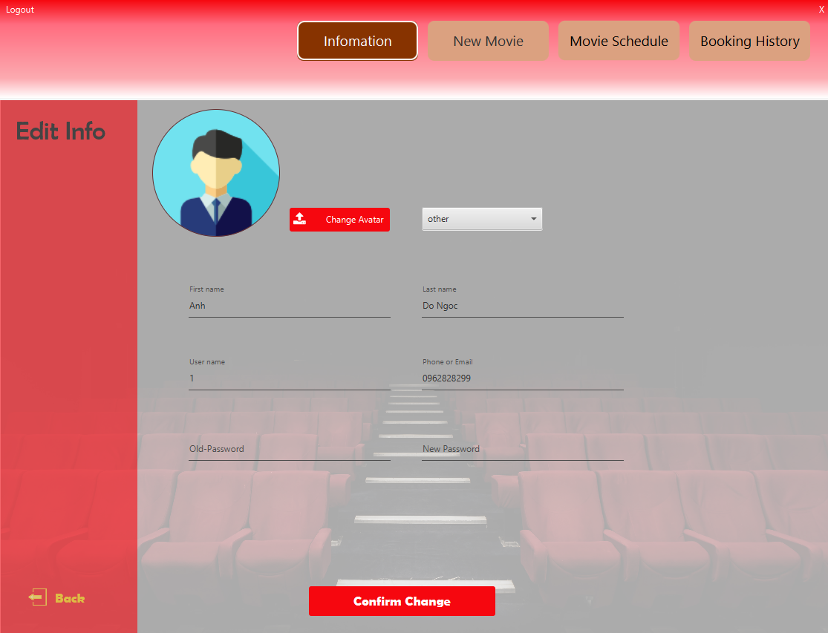

You can turn to the New Movie page to watch upcoming movies. If you cannot click, it means there is no new movie.

Switch to the Movie Schedule page to view showtimes and book tickets.

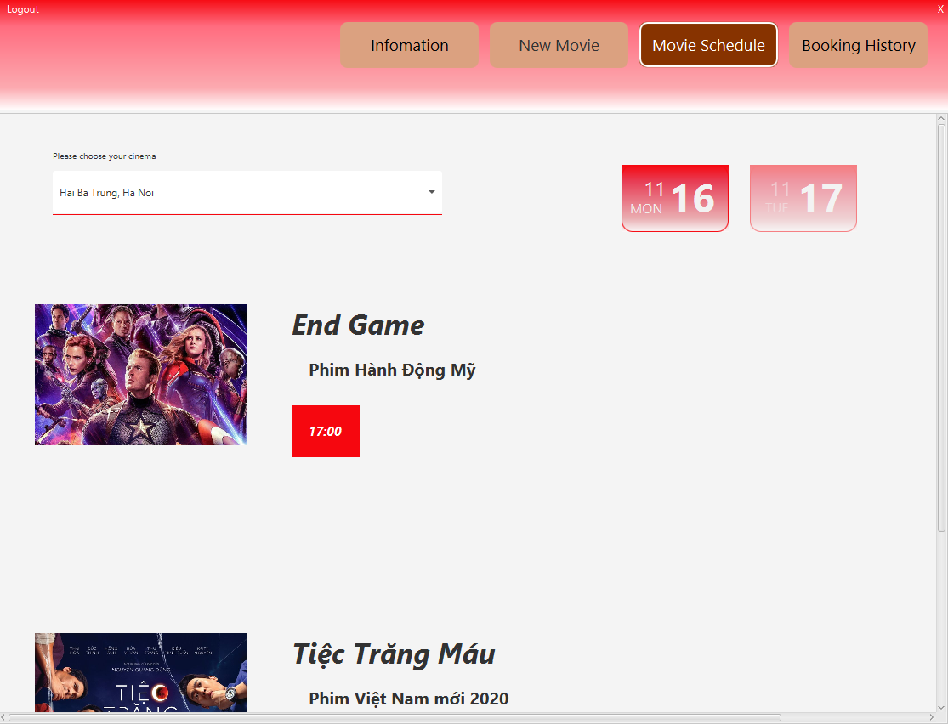

Here when you select the theater branch you want to see, the page will show the movies that will show in that theater today and tomorrow with clear showtimes.

Click on show time to proceed with booking.

The system will display information including branch theater, cinema room, available seats, reserved seats and seat position, choose your desired seat position, we have 2 types: normal and Double seats for you to choose from.

After selecting, the system will automatically jump the price and seat code. If you agree, click on the Book seat button.

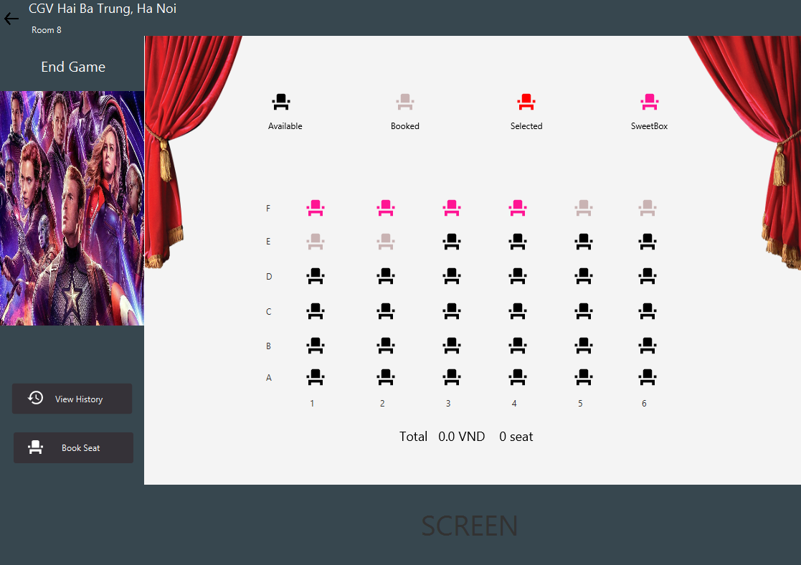

You figure will display a confirmation dialog. If you agree, click Ok, the system will automatically send your email notification (if the information you registered for an account has email address).

At this point, you have completed your booking. Please turn to the Booking History page to see your booking history.

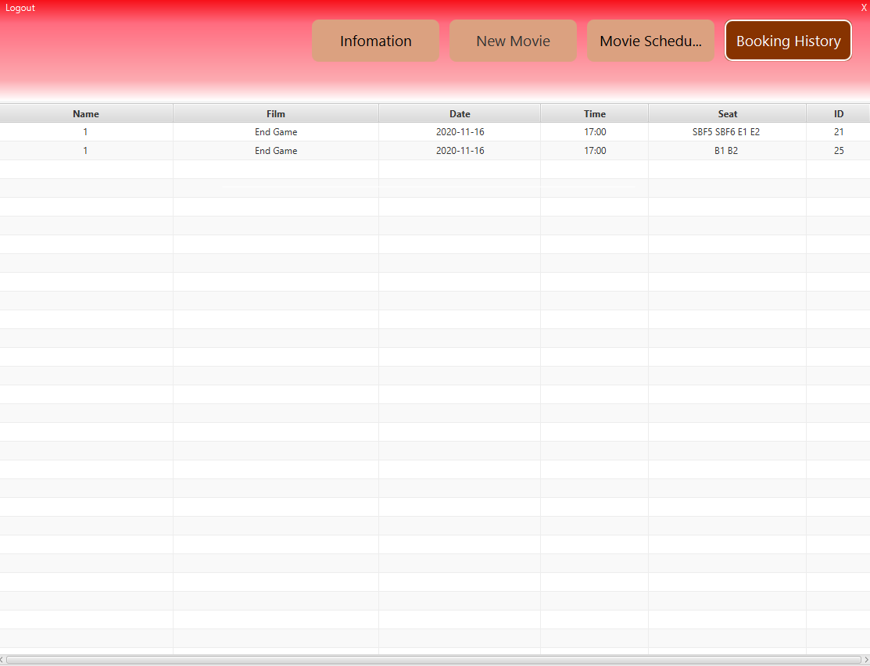

1. Administrator

If you are the administrator, at the start screen, please select the image on the left to access

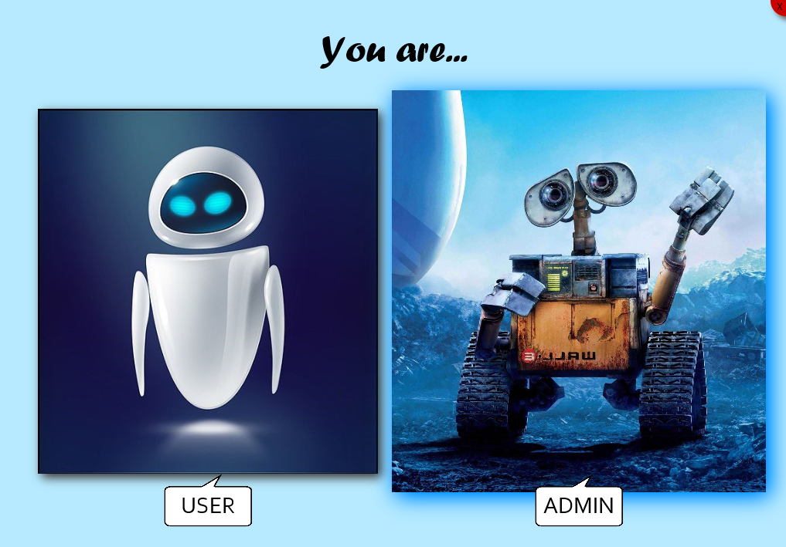

For users who are administrator, we do not allow self-registration of a new account, but we will grant an initial account to the manager.

So after a successful login, this manager has the right to add another account with different positions with different roles.

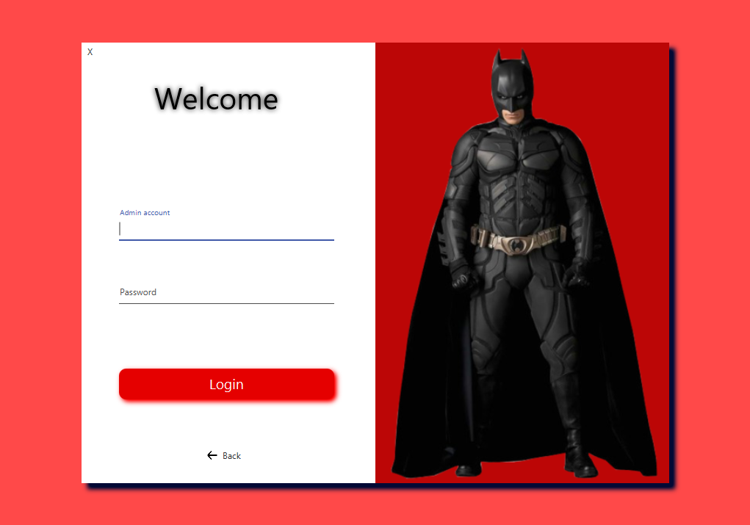

Below is the screen after login, the manager can go to the Custom Info function to change personal information, or switch to the Add People function to add a new person with optional rights. Of course, only the person with the highest authority can access this function

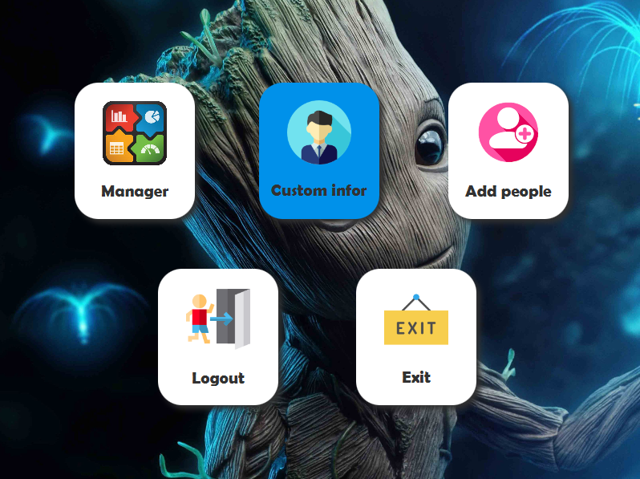

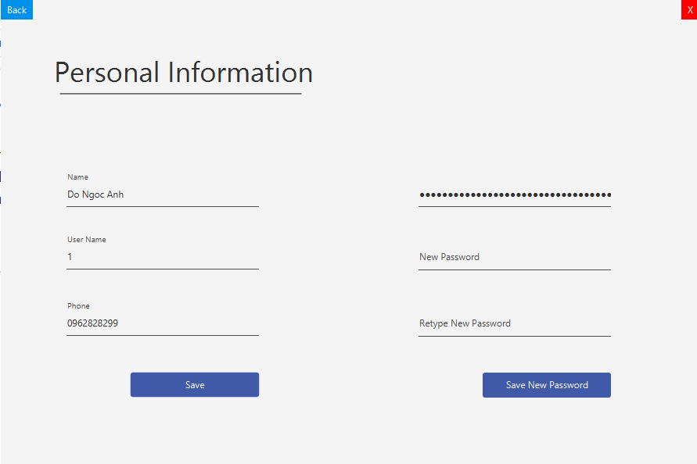

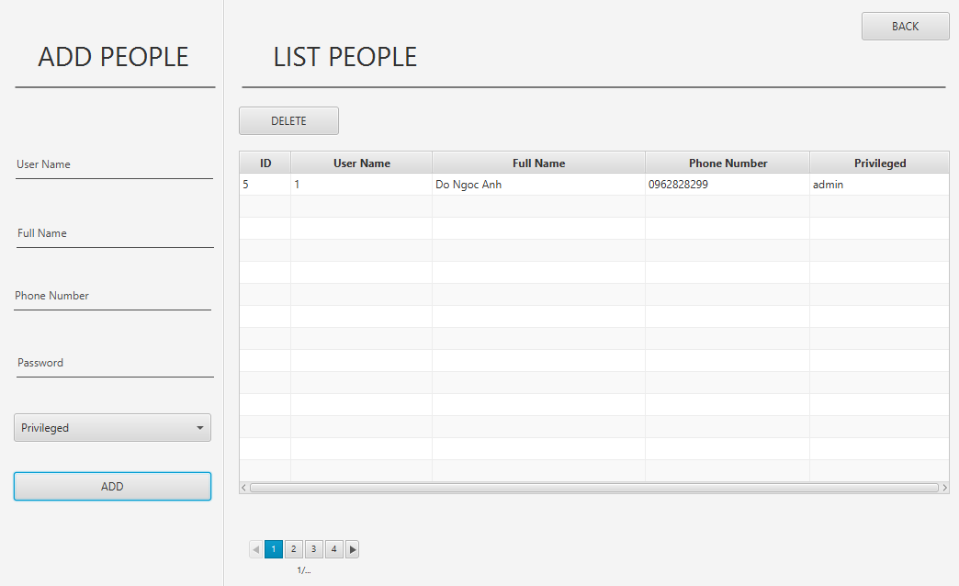

Access to the Manager function to perform the main tasks:

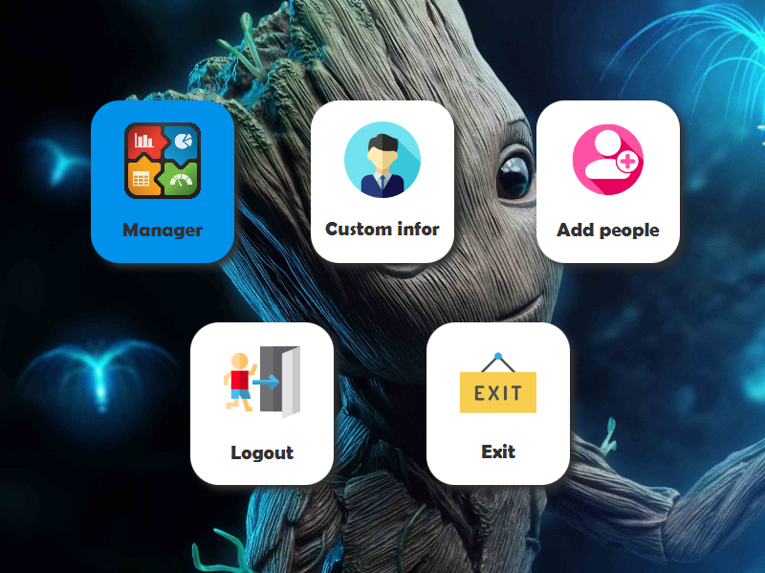

The start-up screen is the dashboard where you can see the current basics aggregated from all movie theaters. You can export the reports as Excel files via the green Export buttons.

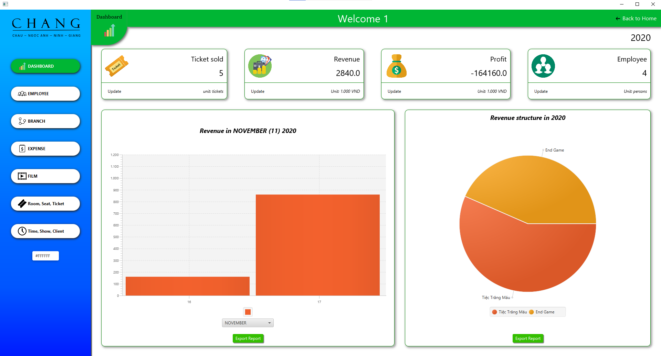

To the Employee function, here you can add, delete an employee, of course we always leave the Export button for you.

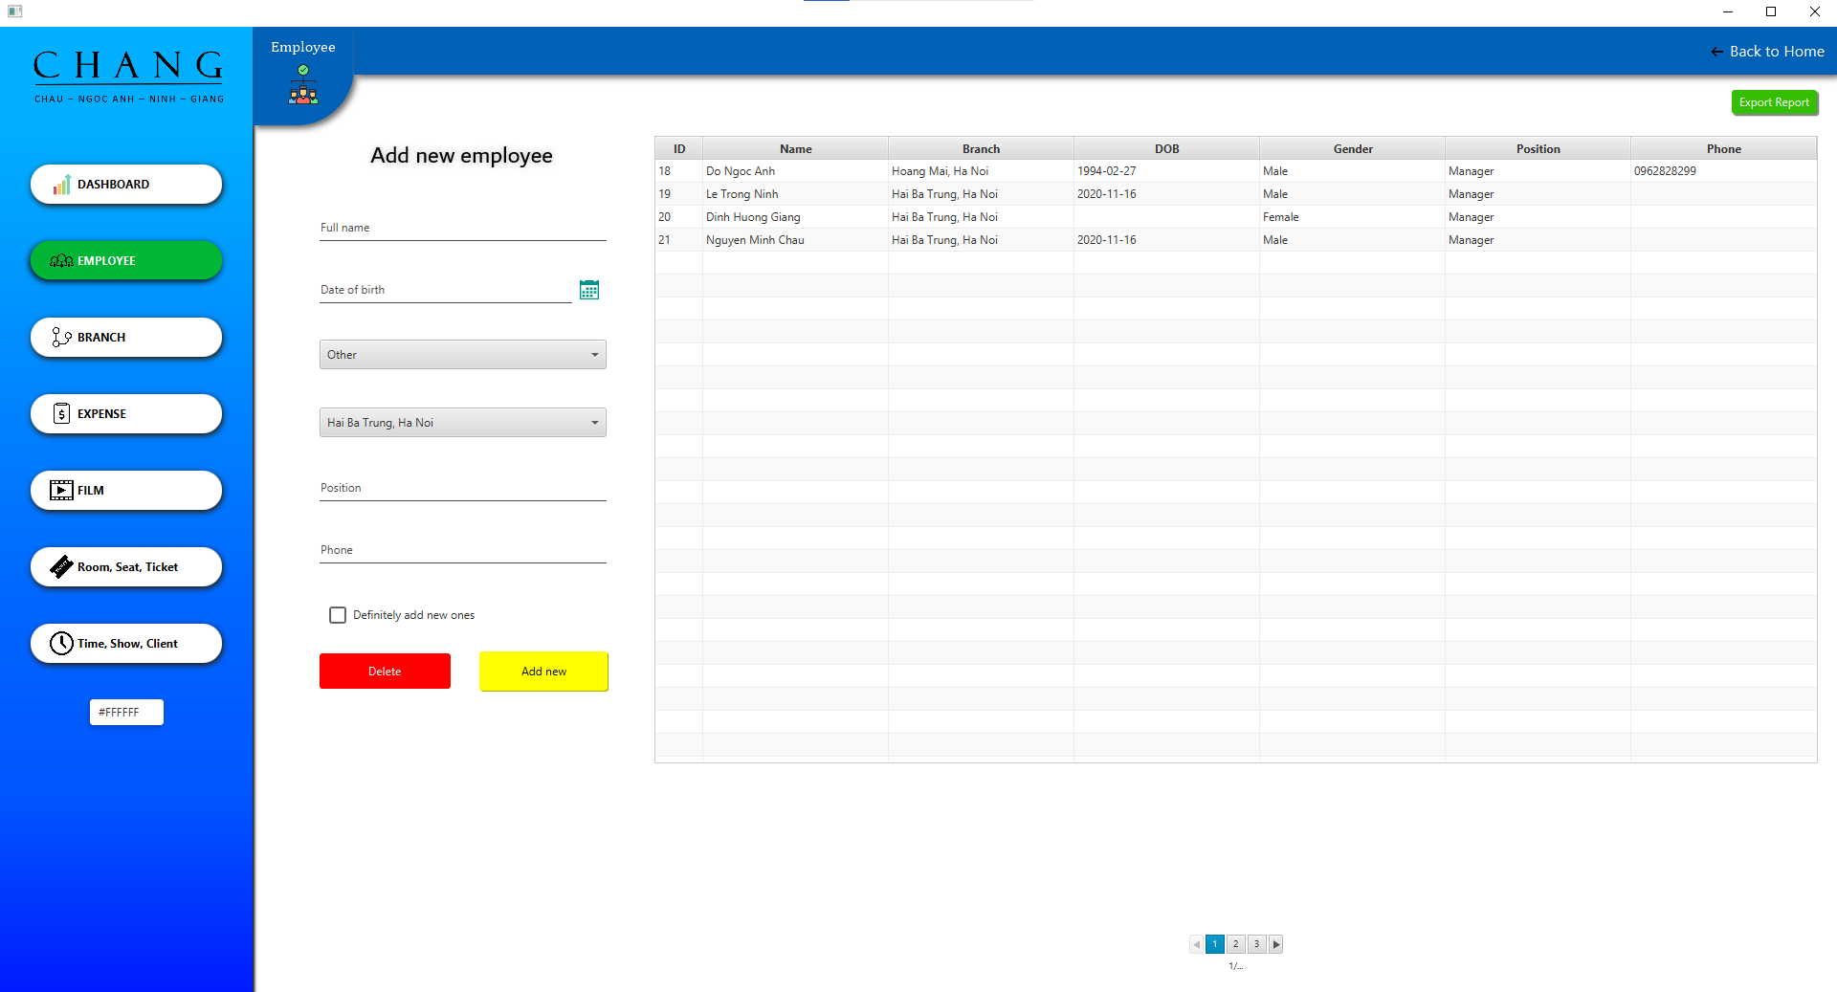

Go to the Branch screen to add, edit, and delete branches:

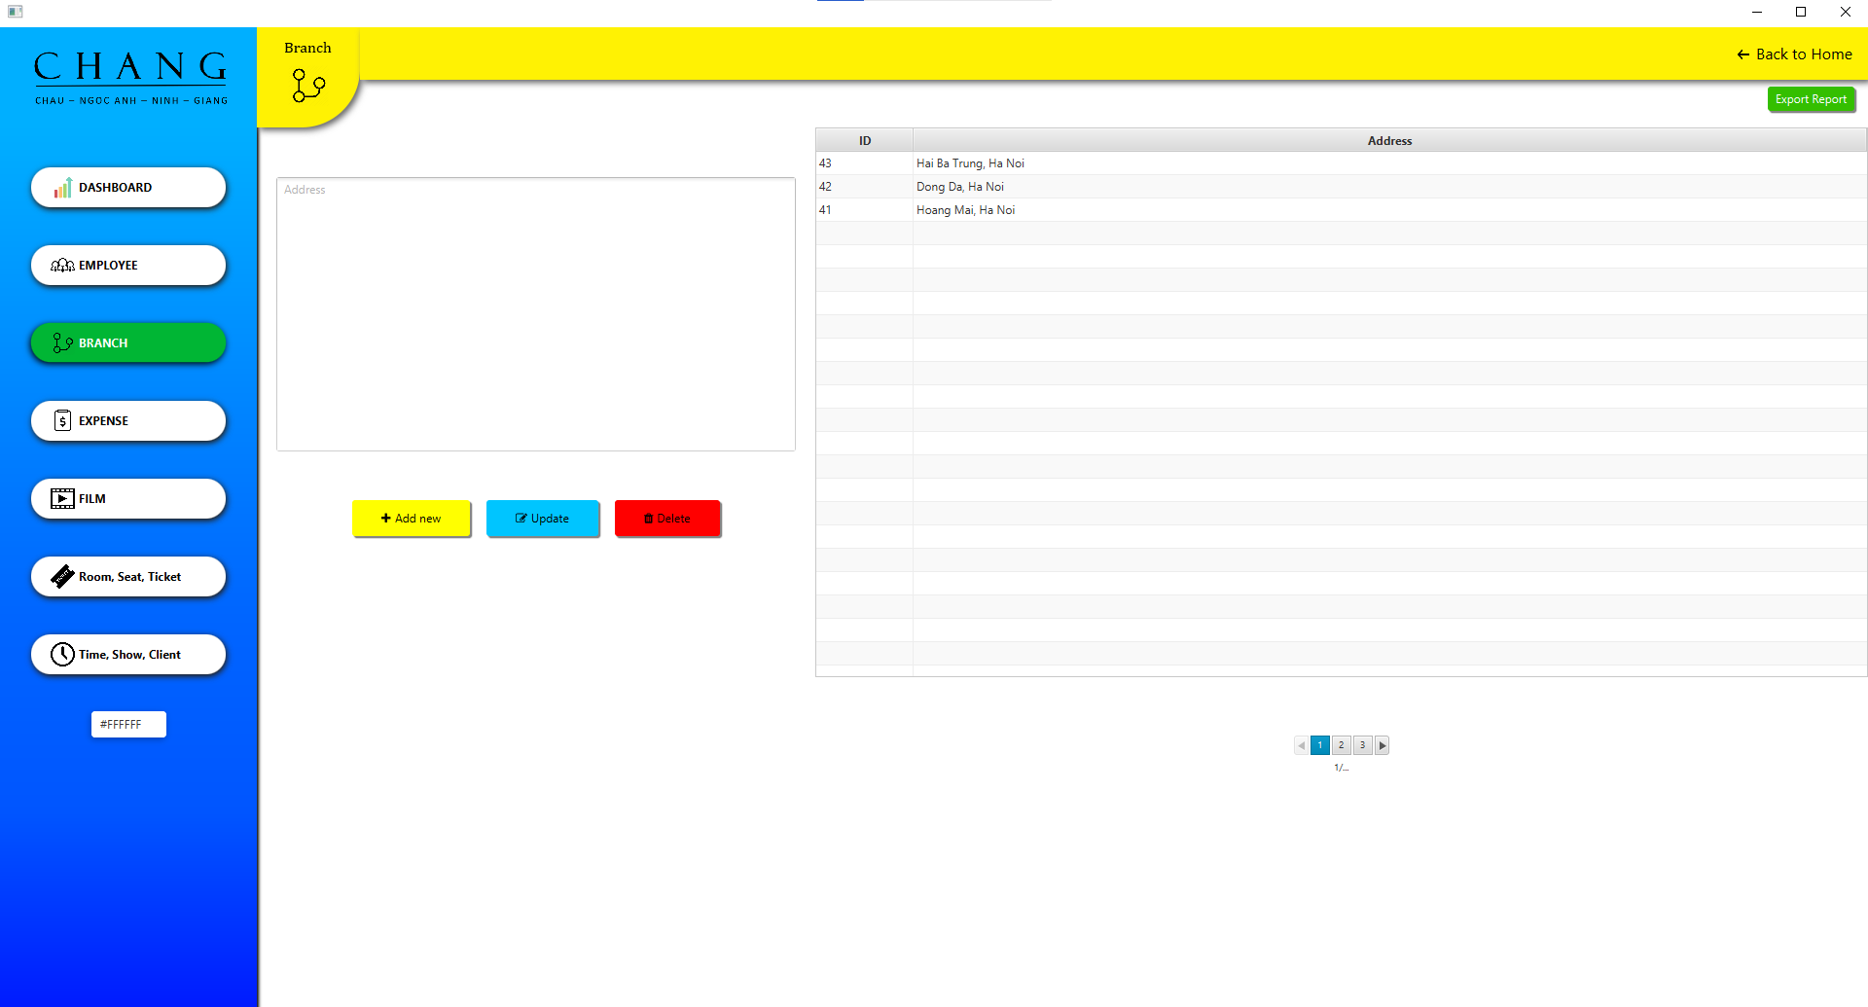

To screen Expense to add, edit, delete expenses. We have for 2 types of expense monitors which are salary expenses and other expenses:

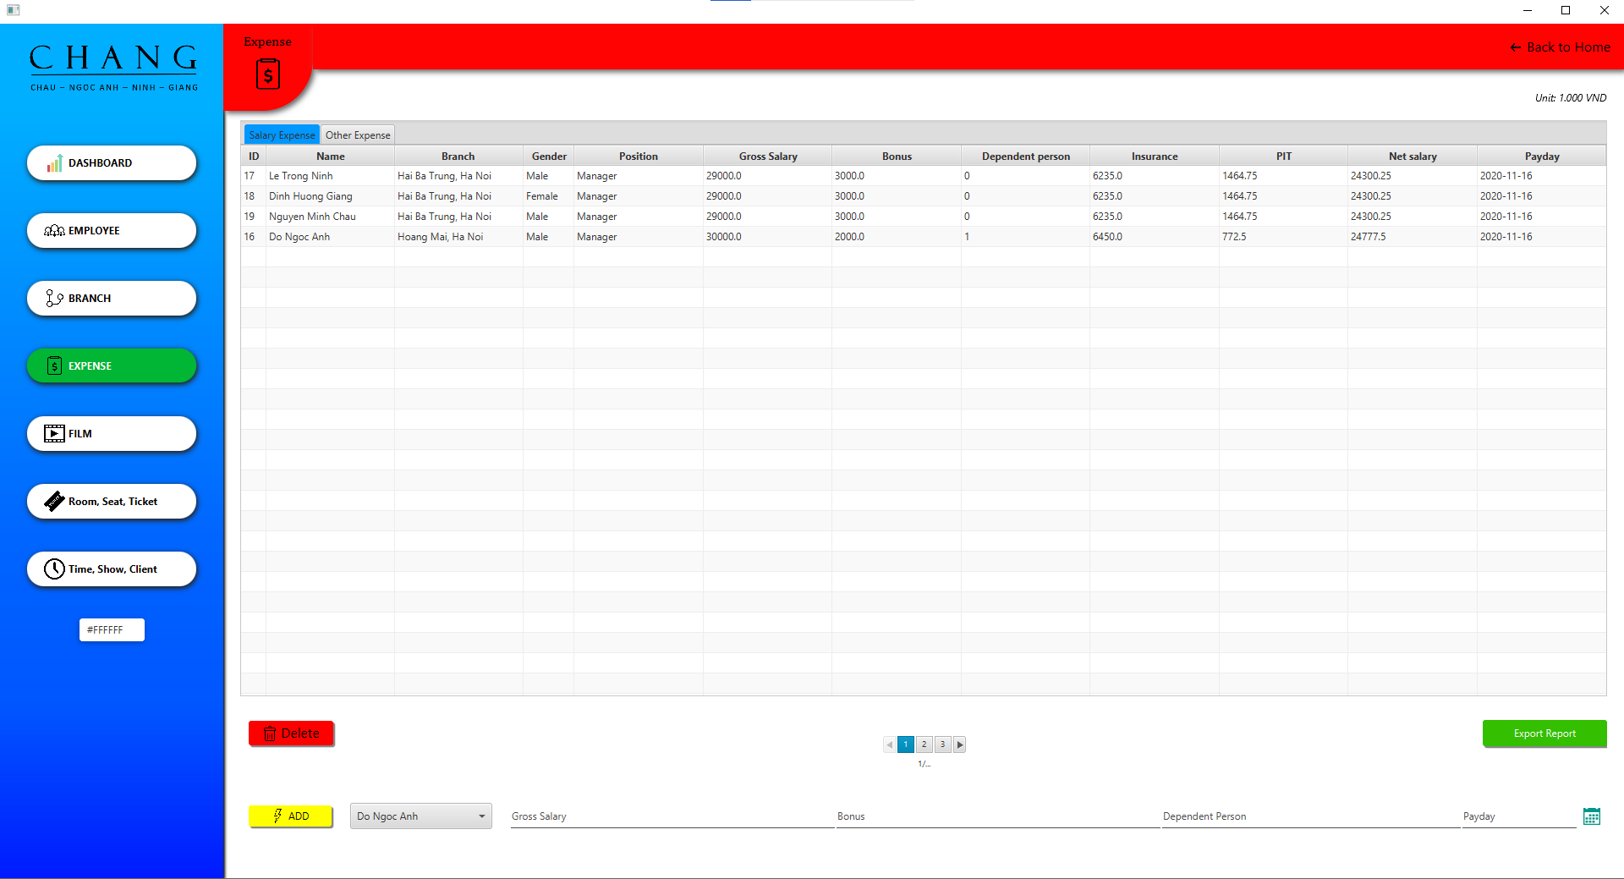

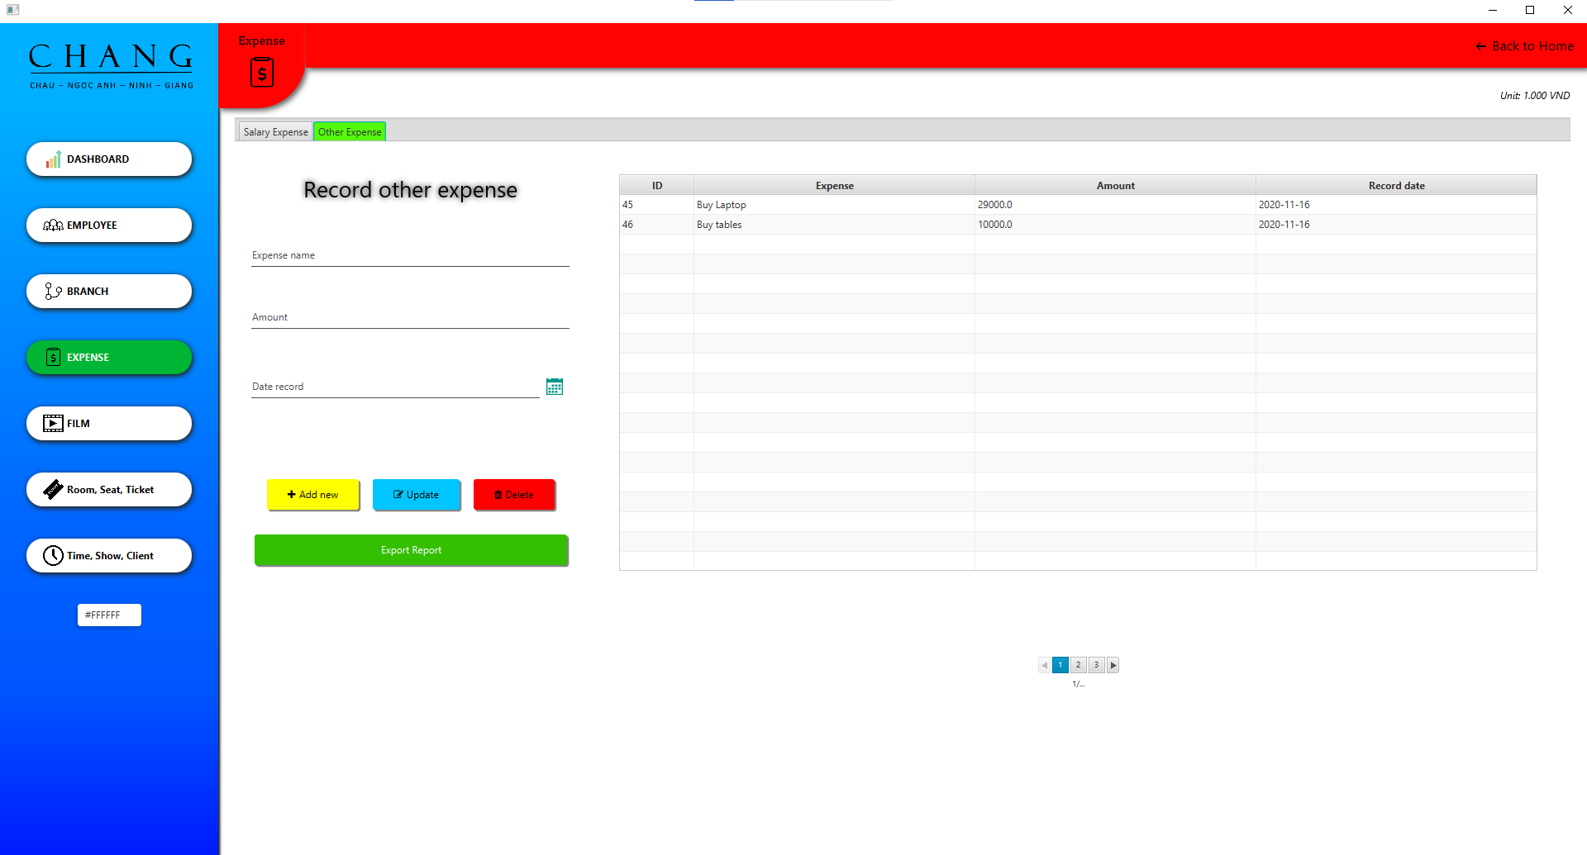

The Film Screen will list all available movies, you can add a new film here

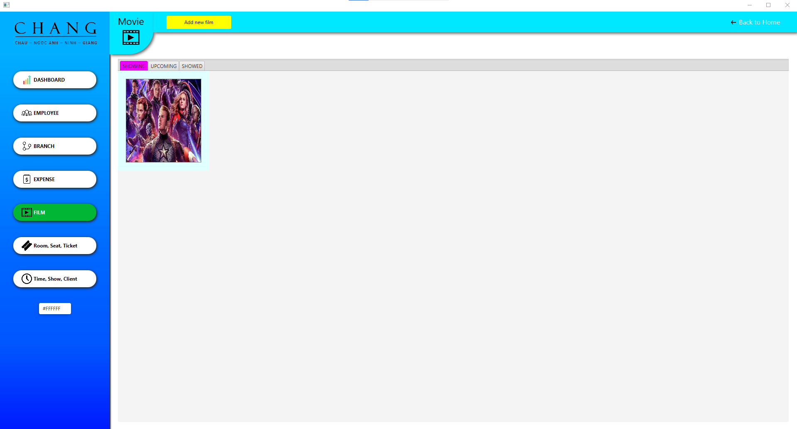

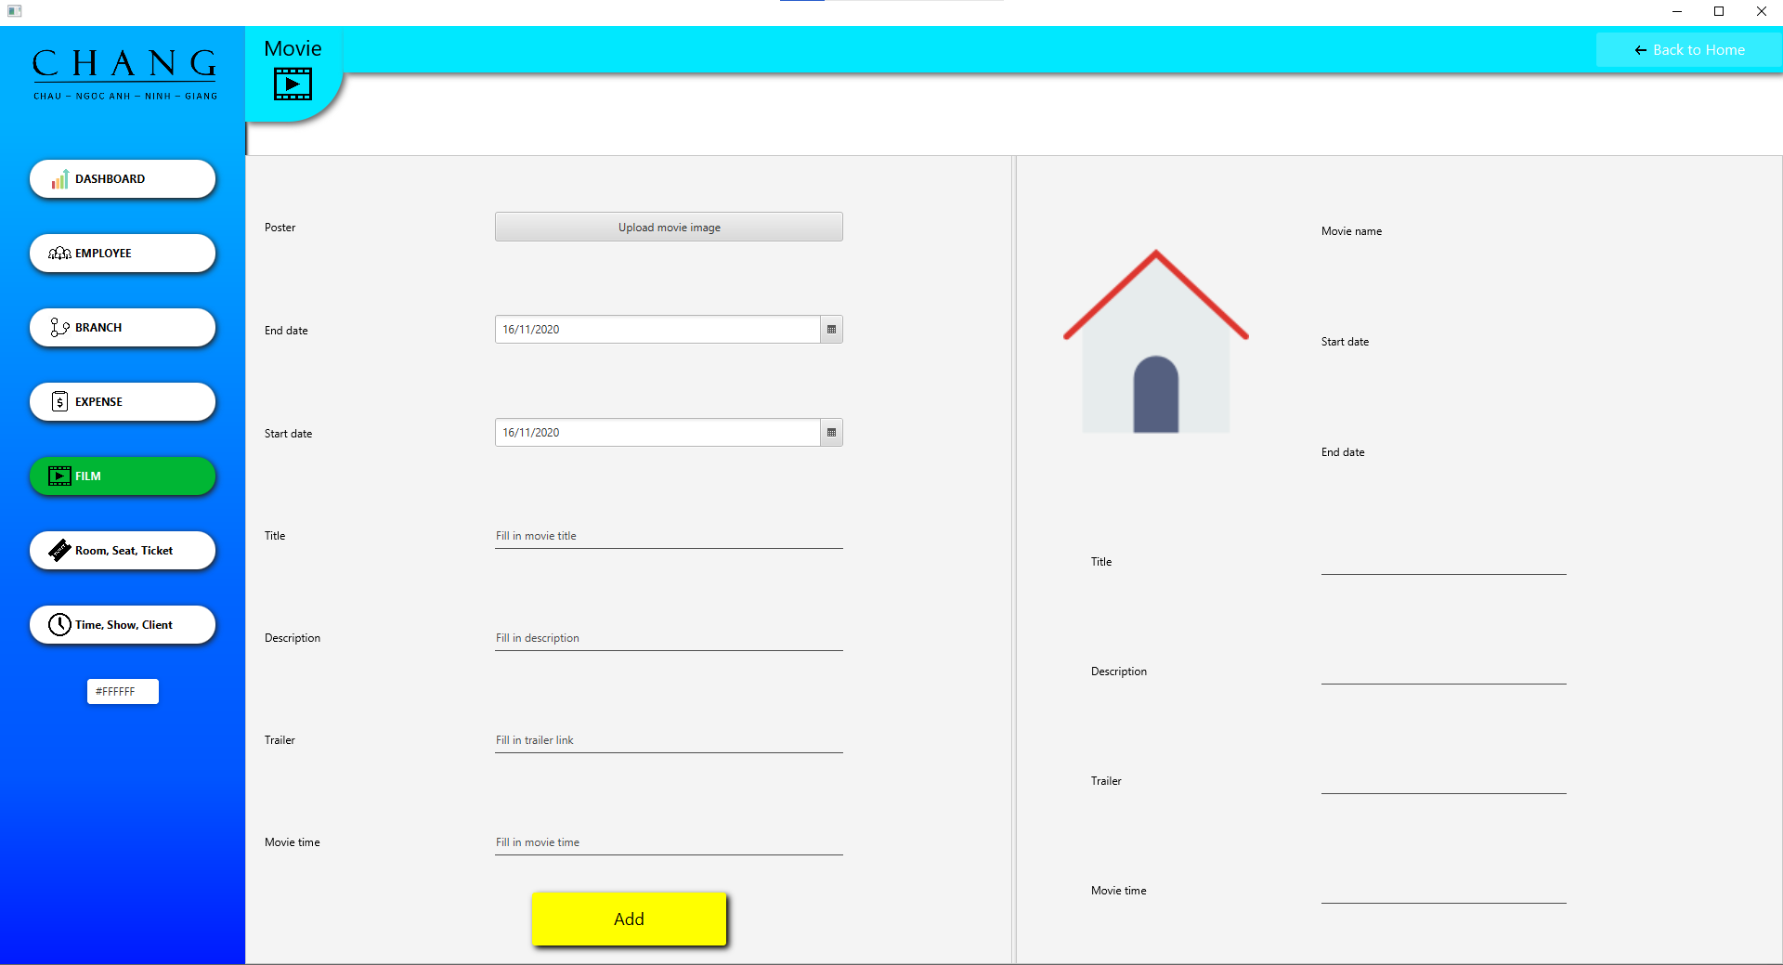

Room, seat, ticket screen is used to manage rooms, seats and tickets sold. We have a Booking Seat button that allows you to jump to a screen where you can directly book seats similar to the Client side in this screen

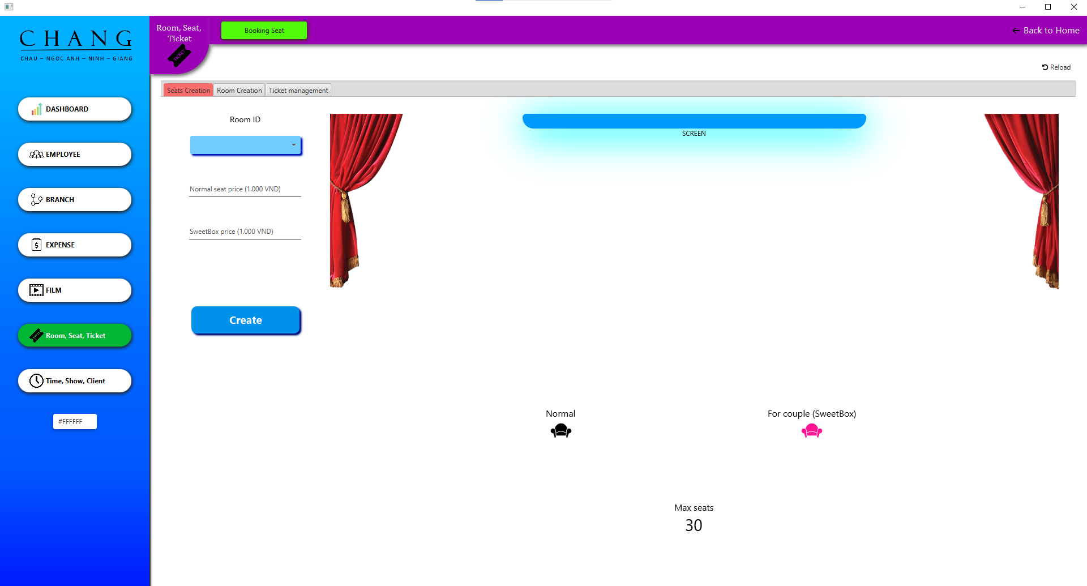

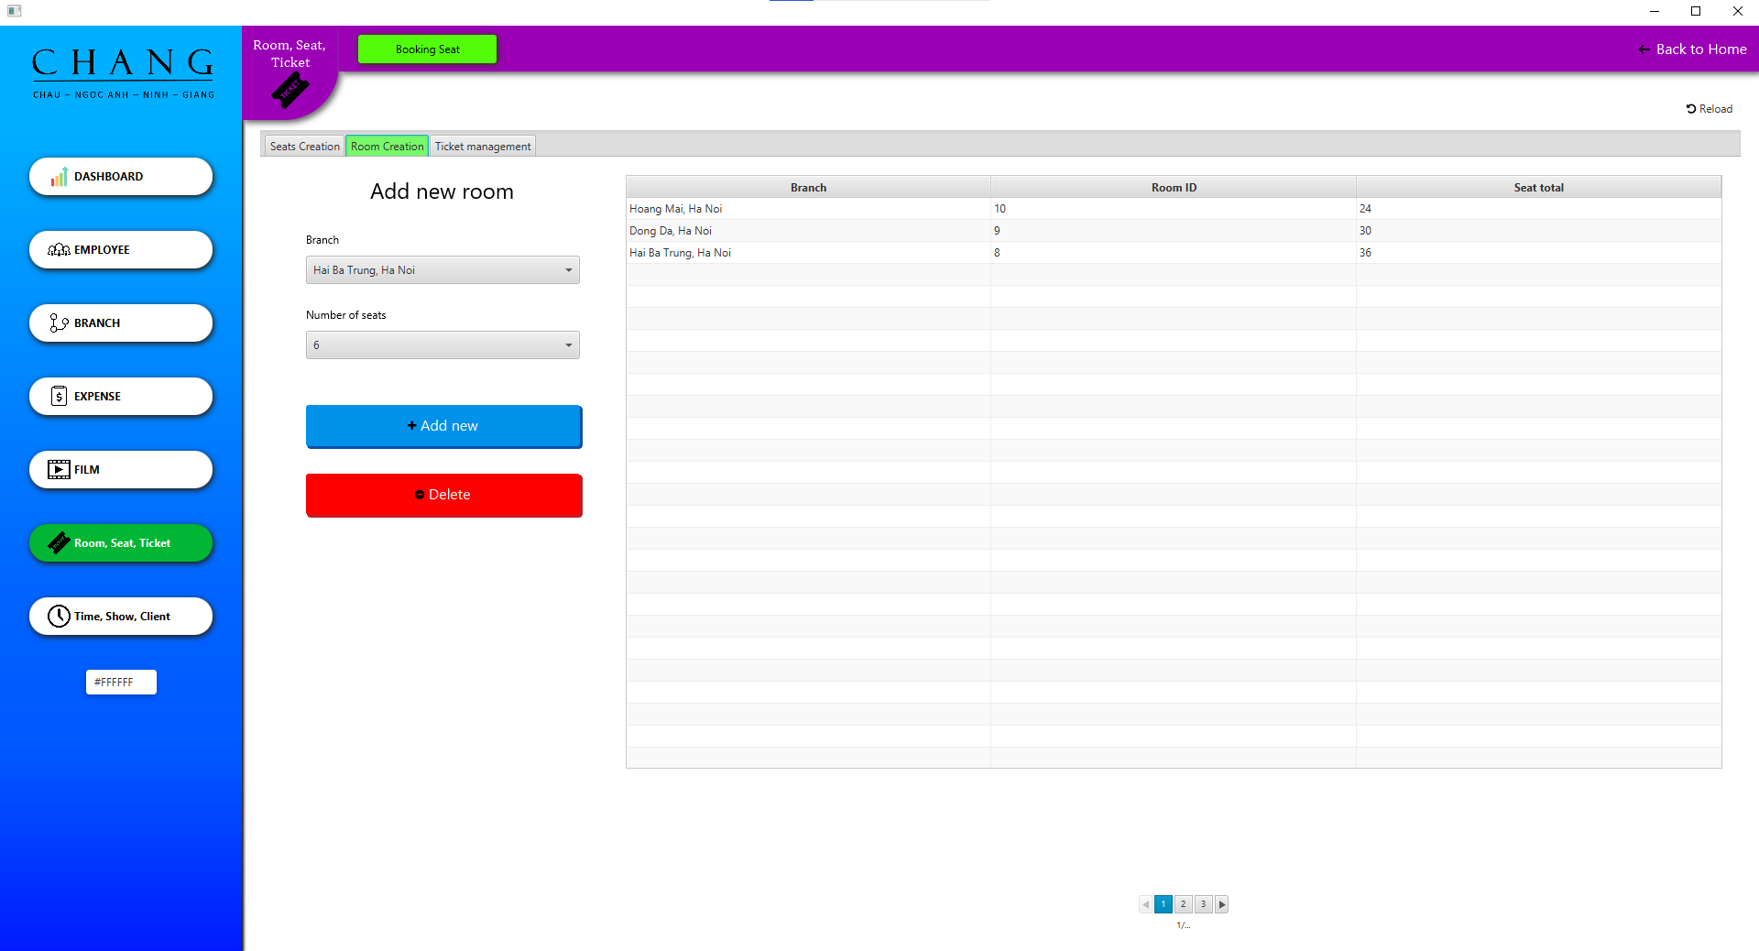

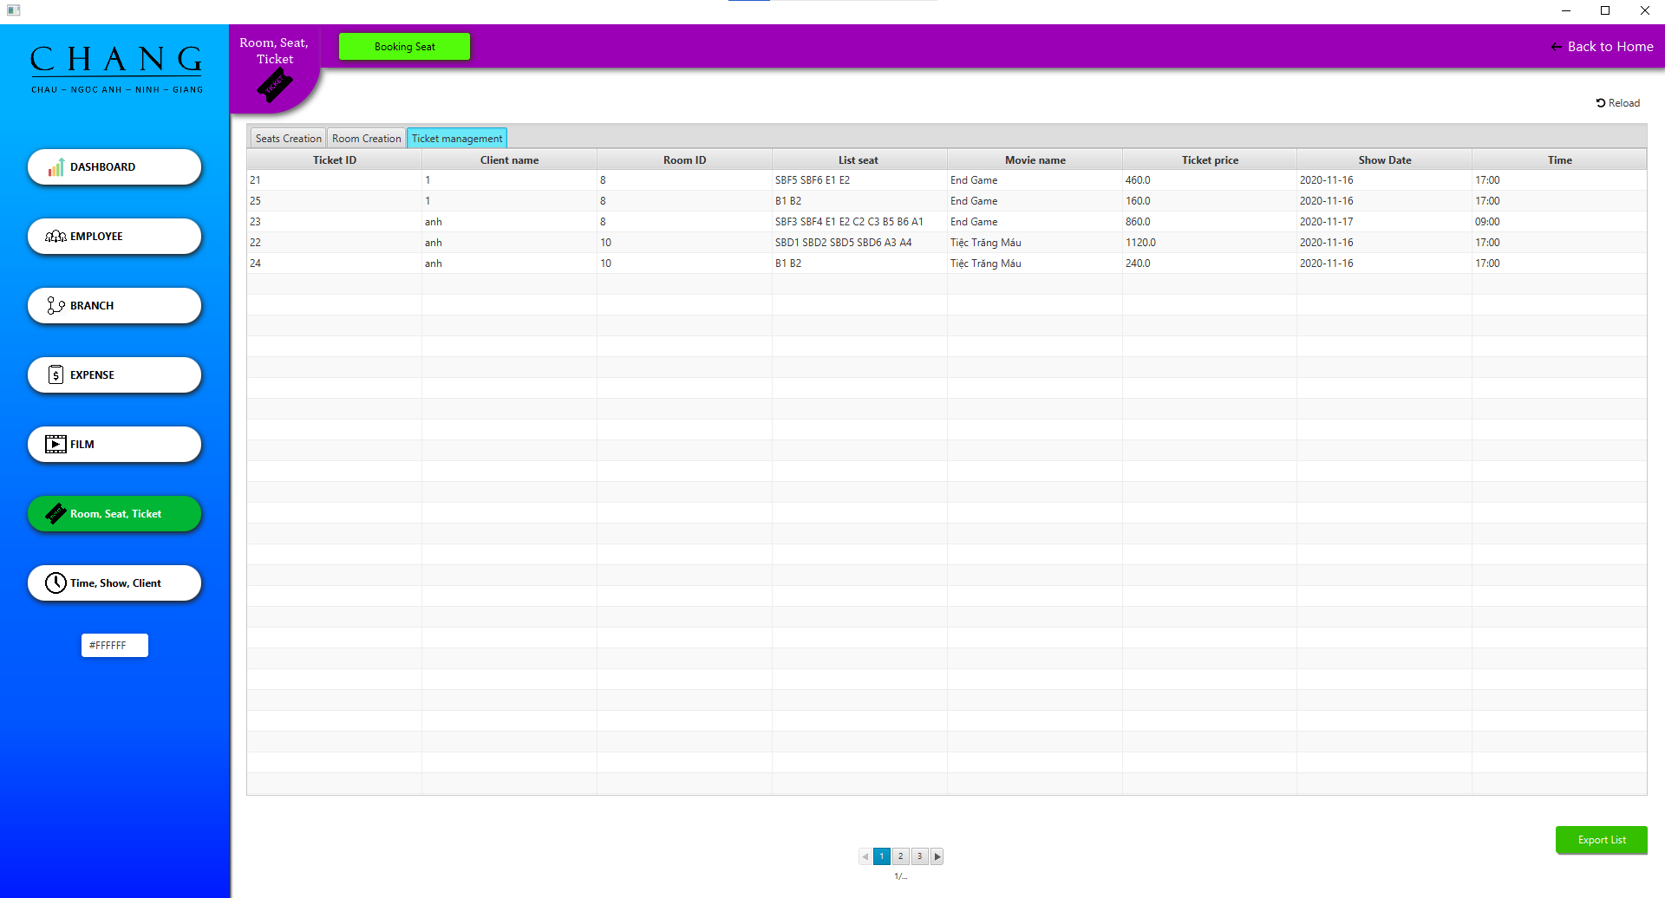

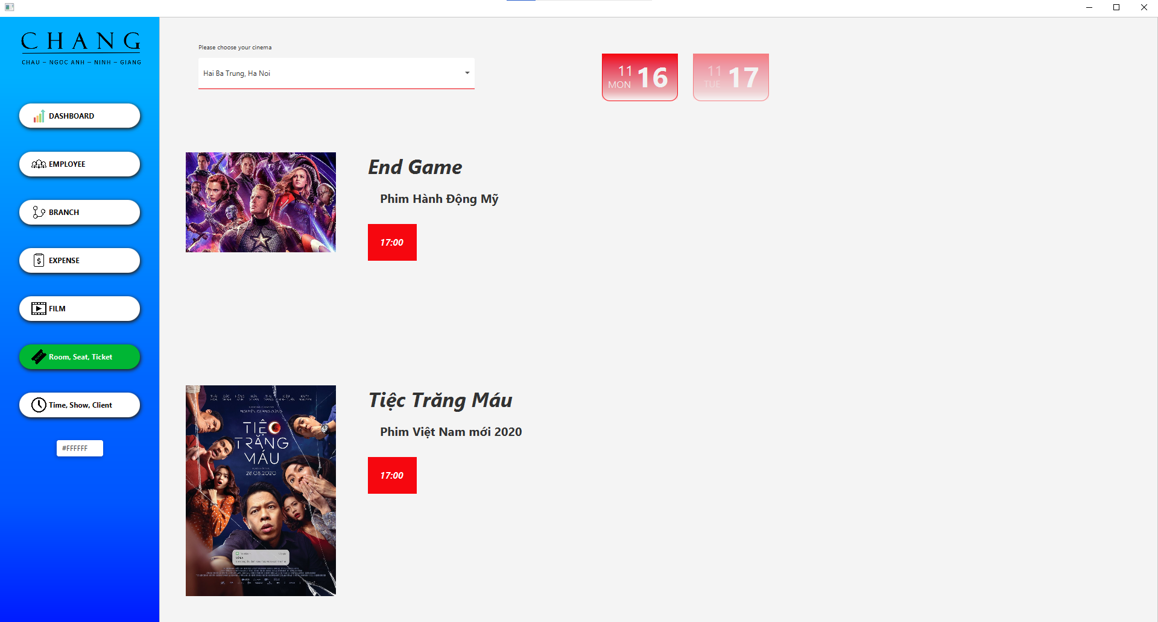

Switch to Time, Show, Client function to set movie show schedule, add time frame and manage client account registered on the system.

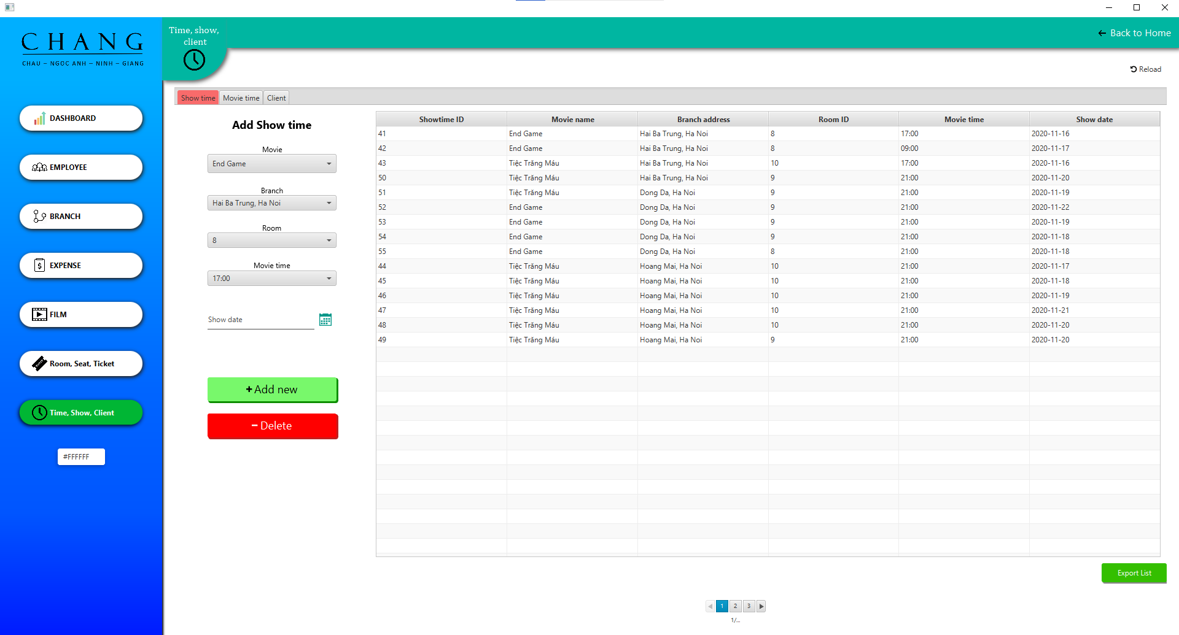

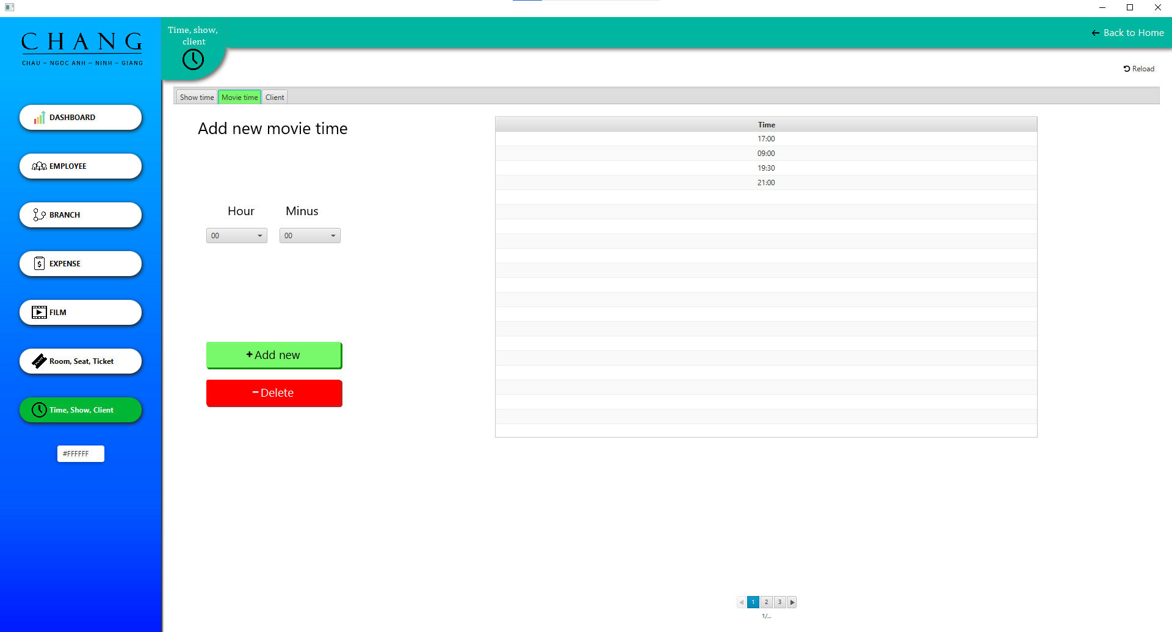

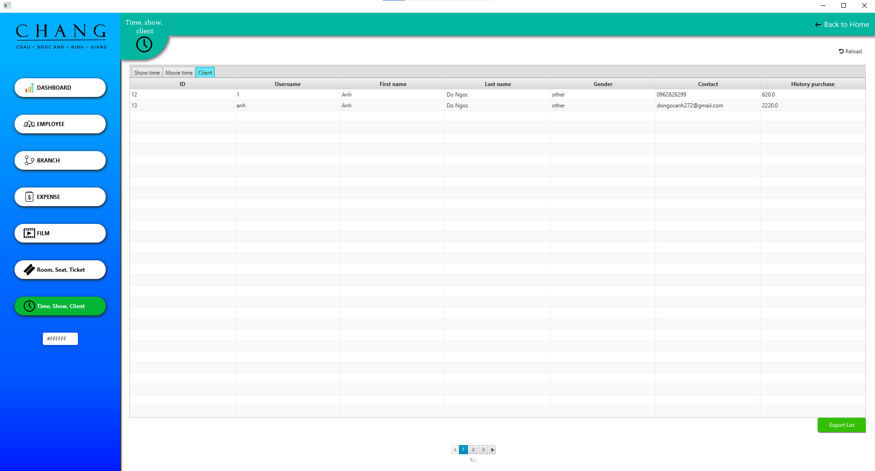

And to keep the management from being tedious, we have a button that allows you to change the Sidebar color to your liking. Of course it won't be saved in memory.

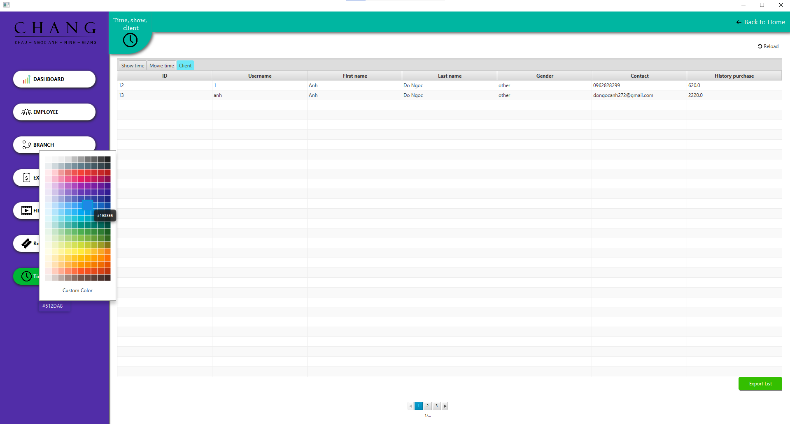

3. FOR DEVELOPER

- Install and configure Java version 1.8

- Install and configure Intellij IDEA Ultimate Edition

- Install SceneBuilder 1.8

- Install and configure Xampp with the same information below:

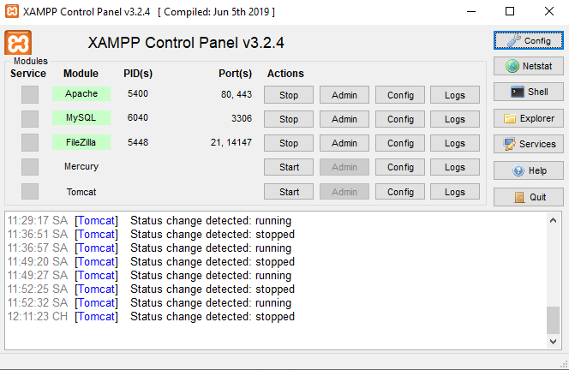

- We use MySQL for this app, make sure your MySQL is up and running.

- Create new database with name is “cinema” and Import the newest database (file *.sql) from the folder path: “~ \CHANGJava\Code\src\database”.

Note: the ~ is your path, which you located project.

- Start Intelliji and open to Folder Code in project

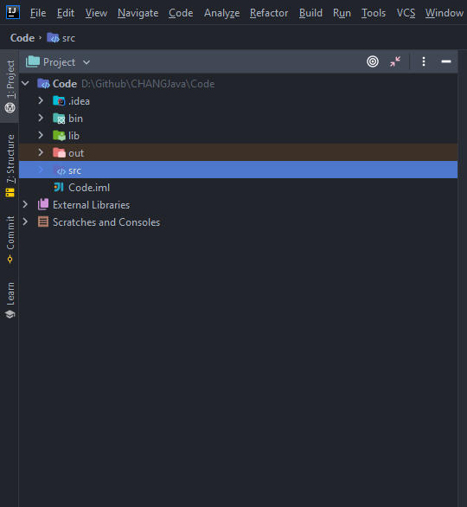

Go to Run -> Edit Configurations… and check if you have the same information below:

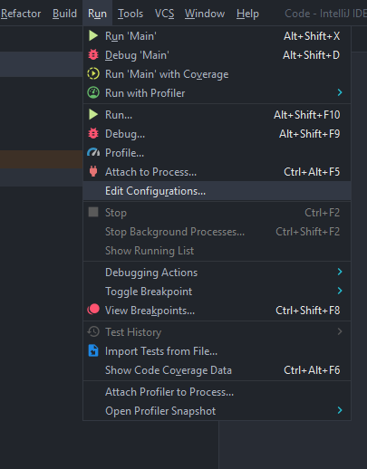

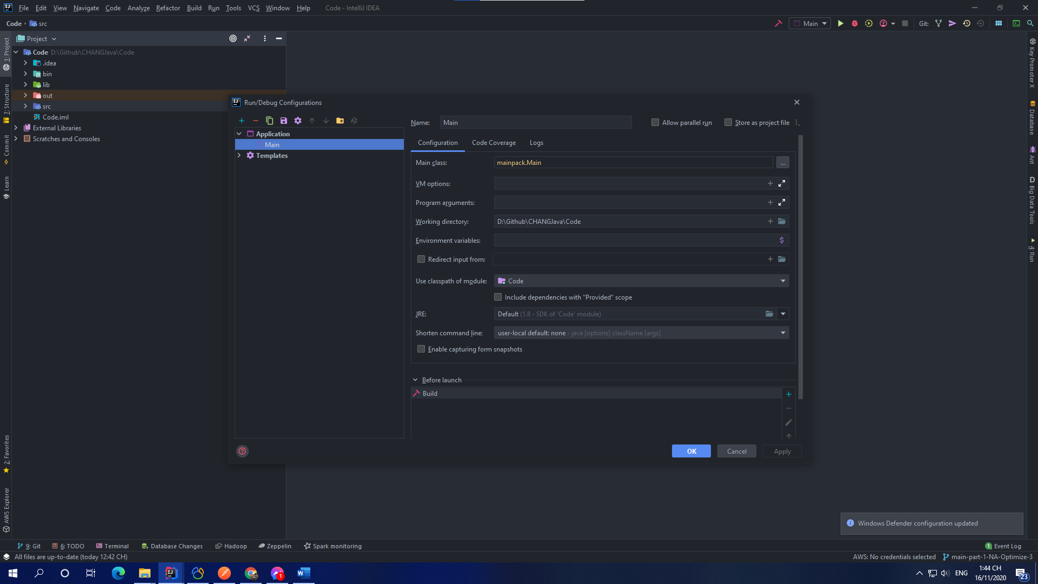

- Go File -> project structure:

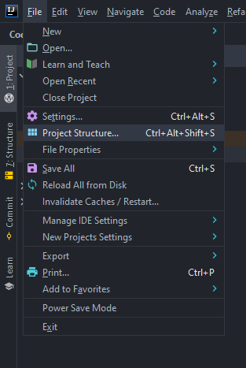

In the Library, if you do exactly, it will be same:

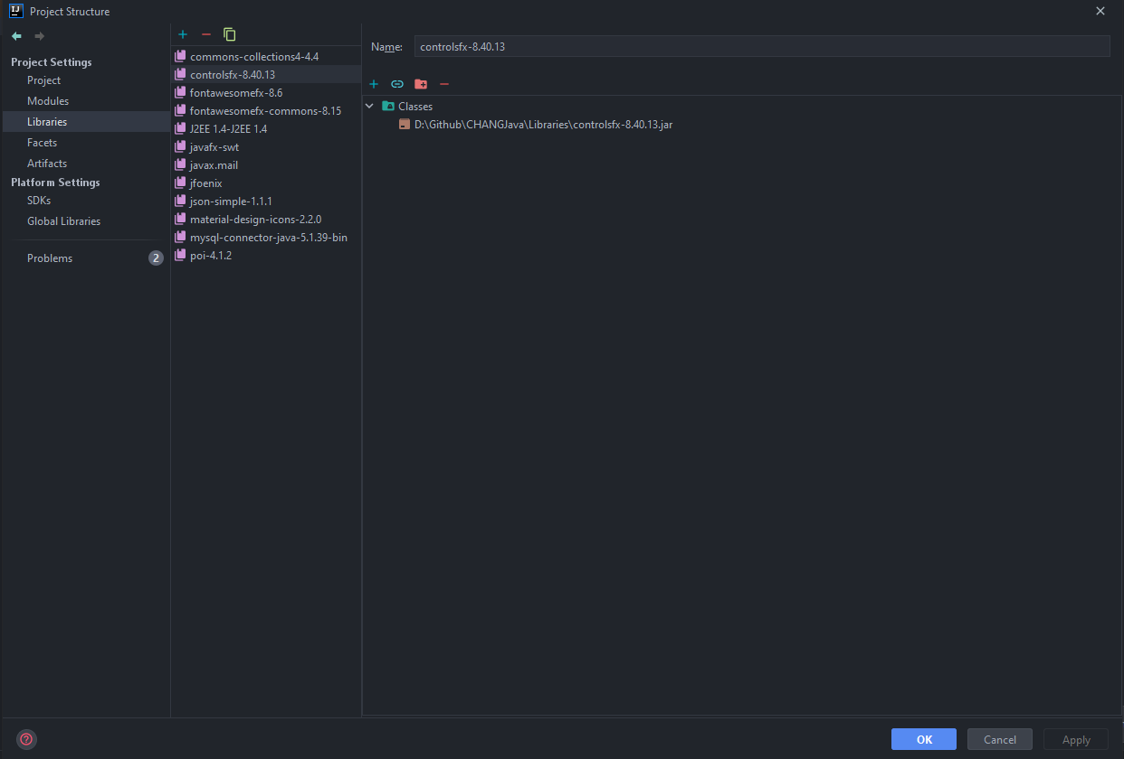

To use Scene Builder, go to File -> setting -> Language & Framework -> javaFx

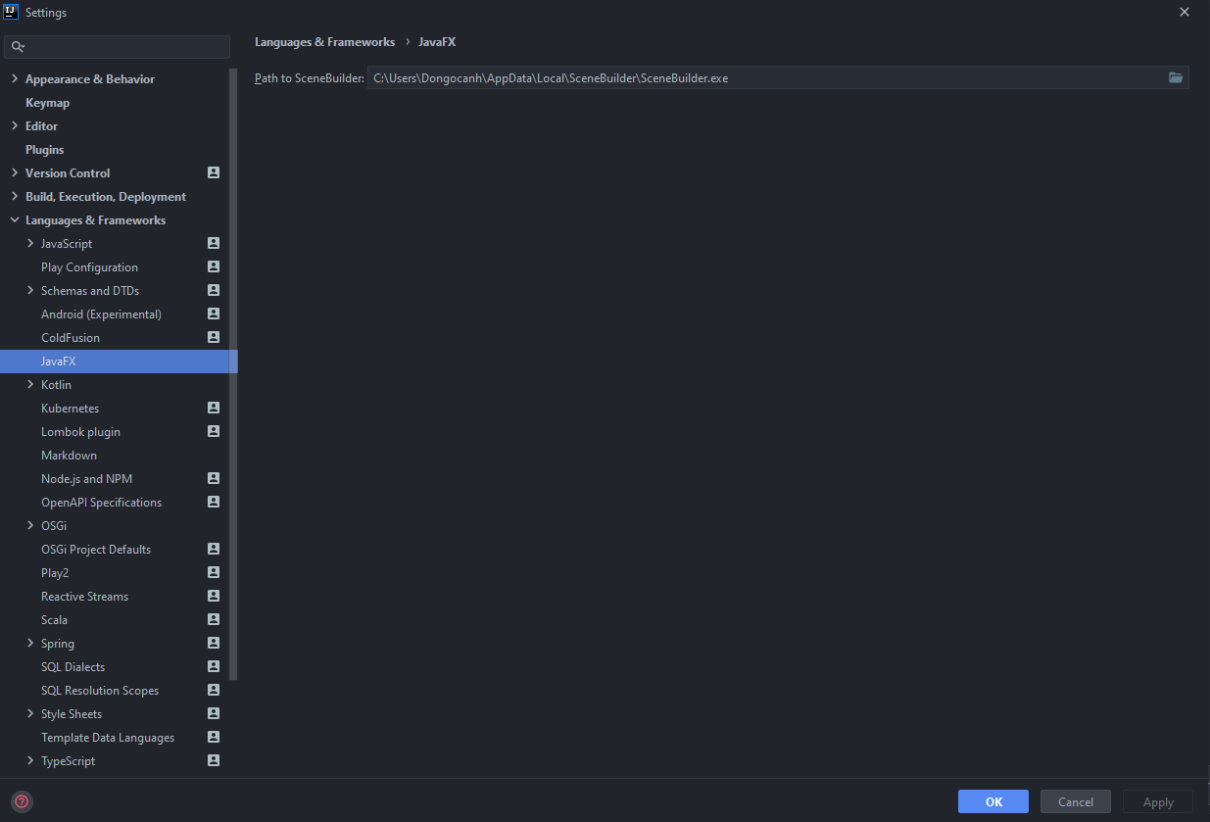

Change the Path of Scene Builder you have installed before.

If every thing is already, go to Run -> Run ‘Main’ to start the App

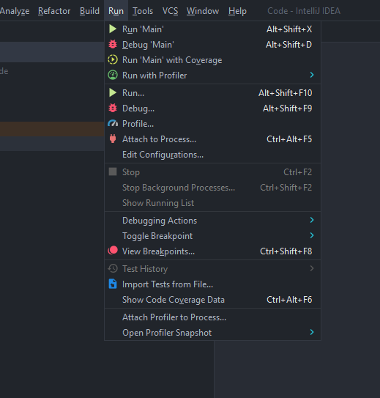

**Thank you for reading this Guide and choosing our system!**